Practical No: 1
Aim: Assignments on Java Generics.

1. Write a Java Program to demonstrate a Generic Class.
Code:
package collection;
class Main1<T> {
T obj;
void add(T obj) {
this.obj = obj;
}
T get() {
return obj;}}
public class MyGeneric {
public static void main(String[] args) {
Main1<Integer> nn = new Main1<Integer>();
nn.add(11);
Main1<String> ss = new Main1<String>();
ss.add("Anchal Singh 119");
System.out.println("Member of My Generic Class<Integer>: " + nn.get());
System.out.println("Member of My Generic Class<String>: " + ss.get());}}

Output:
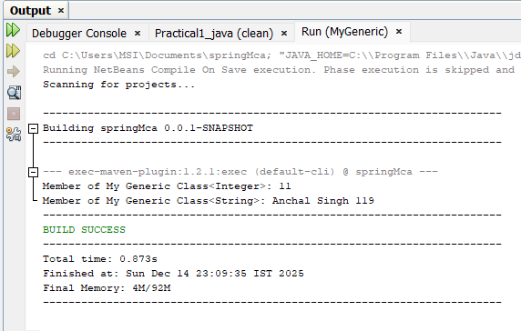

2. Write a Java Program to demonstrate Generic Methods.
Code:
package collection;
public class GenericMethod {
public static <T>void printGenericArray(T[] items) {
for(T item : items) {
System.out.print(item+"");
}
System.out.println();
}
public static void main(String[] args) {
Integer[] int_Array= {1,2,4,5,6,11};
Character[] char_Array = {'A','N','C','H','A','L'};
System.out.println("Integer Array contents: ");
printGenericArray(int_Array);
System.out.println("Character Array contents: ");
printGenericArray(char_Array );
}

}

Output:

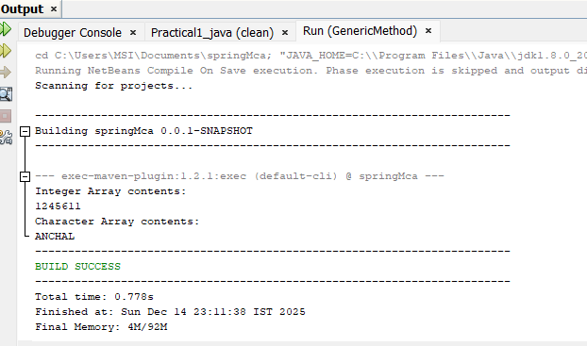

3. Write a Java Program to demonstrate Wildcards in Java Generics.
1) Unbound:

package collection;
import java.util.Arrays;
import java.util.List;
public class Unbounded {
public static void main(String[] args) {
List<Integer> list1 = Arrays.asList(1, 1, 9);
List<Double> list2 = Arrays.asList(1.1, 2.2, 3.3);
printlist(list1);
printlist(list2);

}
private static void printlist(List<?> list) {
System.out.println(list);
}
}

Output:

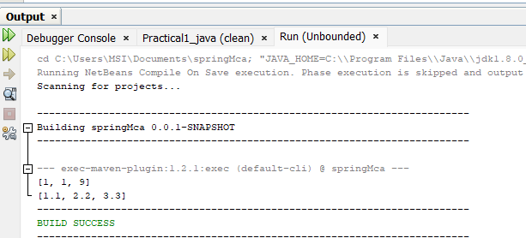

2) Lowerbound

package collection;

import java.util.Arrays;
import java.util.List;

public class lowerbound { // Class name should start with uppercase

public static void main(String[] args) {
// List of Integers
List<Integer> list1 = Arrays.asList(5, 8, 6, 7, 11);
superClass(list1);

// List of Numbers (Number is a superclass of Integer)
List<Number> list2 = Arrays.asList(4, 8, 55, 7, 41);
superClass(list2);
}

// Method accepts List of Integer or any superclass of Integer
public static void superClass(List<? super Integer> list) {
System.out.println("Anchal Singh 119");
System.out.println(list);
}
}

Output:

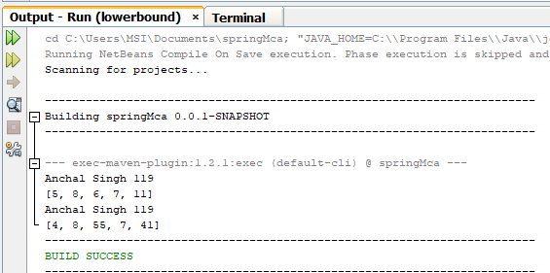

3) UpperBounded

package collection;
import java.util.*;
public class upperbound<T> {
private static Number sum(List<? extends Number>numbers) {
double a=0.0;
for(Number n:numbers)
a+=n.doubleValue();
return a;}

public static void main(String[] args) {
System.out.println("Anchal Singh 119");
List<Integer>list1=Arrays.asList(1,1,9,7,13);
System.out.println(sum(list1));

List<Double>list2=Arrays.asList(4.2,8.5,5.5,77.7,4.1);
System.out.println(sum(list2));

}
}

Output:

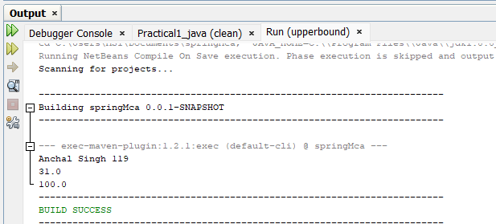

Practical No: 2

Aim: Assignments on List Interface.

1. Write a Java program to create a List containing items of type String and use for- each loop to print the items of the list.
Code:
package collection;
import java.util.*;
public class ArrayListDemo {
public static void main(String args[]) {
ArrayList<String> list = new ArrayList<String>();
list.add("Anchal");
list.add("Singh");
list.add("119");
System.out.println("ArrayList:" + list);
//System.out.println("root is at index: " + list.indexOf(10));
for(String s:list){
System.out.println(s);
}
}}

Output:

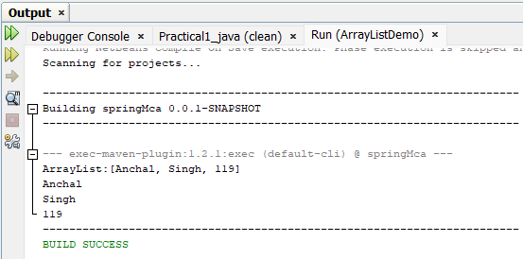

2. Write a Java program to create a List containing a list of items and use ListIterator interface to print items present in the list. Also print the list in reverse/ backward direction.

Code:

package collection;
import java.util.ArrayList;
import java.util.Iterator;
public class ReverseArrayList {
public static void main(String[] args) {
ArrayList<String>arr = new ArrayList<String>();
arr.add("Anchal");
arr.add("Singh");
arr.add("119");
System.out.println(arr);
Iterator<String> it= arr.iterator();
for (int i = arr.size()-1; i >=0; i--) {
System.out.println(arr.get(i));
}

}}

Output:

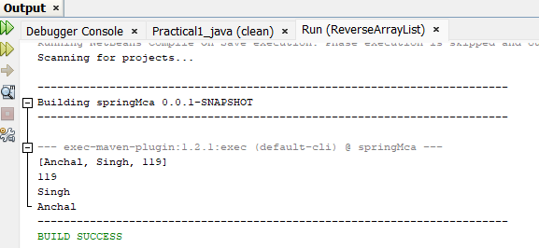

Practical No: 3

Aim:Assignments on Set Interface.

1. Write a Java program using Set interface containing list of items and perform the following operations:
a. Add items in the set.
b. Insert items of one set into another set.
c. Remove items from the set
d. Search the specified item in the set
Code:
package collection;
import java.util.*;
public class Hash_Set {
public static void main(String[] args) {
Set<String>hset=new HashSet<String>();
//Add Function
hset.add("Anchal");
hset.add("Singh");
hset.add("119");
hset.add("Papaya");
hset.add("Grapes");
System.out.println("After Using Add Function: "+hset);
//Remove Function
hset.remove("Mango");
System.out.println("After Using Remove Function: "+hset);
String check="Papaya";
System.out.println(hset);
System.out.println("Contain "+" "+ check+" "+"is "+hset.contains(check)+".");
Set<String> hset1 = new HashSet<String>();
hset1.addAll(Arrays.asList(new String[] { "ABC", "XYZ", "MNO", "EFG" }));
Set<String> hset2 = new HashSet<String>();
hset2.addAll(Arrays.asList(new String[] { "KLM", "HIJ", "PQR", "STY" }));
Set<String> union = new HashSet<String>(hset1);
union.addAll(hset2);
System.out.println("Union of the hset1 and hset2 Set: ");
System.out.println(union);}}
Output:
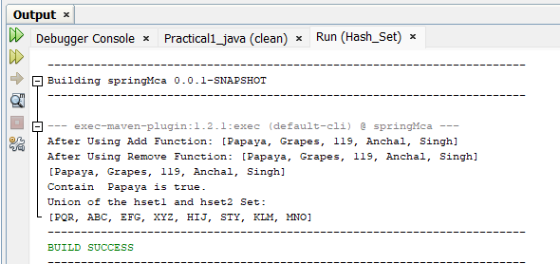

Practical No:4
Aim: Assignments on Map Interface

Write a Java program using Map interface containing list of items having keys and associated values and perform the following operations:
a. Add items in the map.
b. Remove items from the map
c. Search specific key from the map
d. Get value of the specified key
e. Insert map elements of one map into another map.
f. Print all keys and values of the map

Code:

package collection;
import java.util.*;
public class MapInterface {
public static void main(String[] args)
{
Map<Integer, String> map1 = new HashMap<Integer, String>();

map1.put(new Integer(1), "Anchal");
map1.put(new Integer(2), "Singh");

map1.put(new Integer(3), "MCA");
map1.put(new Integer(4), "FY");

map1.put(new Integer(5), "Hello");
map1.put(new Integer(6), "World");
System.out.println(map1);
map1.remove(new Integer(3));
System.out.println(map1);
System.out.println("Key 3 is present "+map1.containsKey(3));
String val=(String)map1.get(4);

System.out.println("Value of specified key: "+val);
Map<Integer, String> map2 = new HashMap<Integer, String>();
map2.put(6, "Ritika");
map2.put(7, "Snehal");
map2.put(8, "Radhika");
map2.put(9, "Nikita");
map1.putAll(map2);
System.out.println(map1);
}
}

Output:
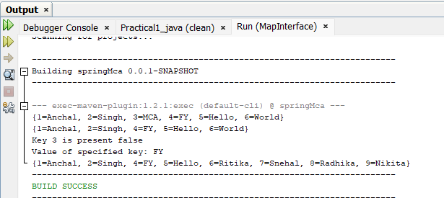

Practical No: 5
Aim:Assignments on Lambda Expression.

1. Write a Java program using Lambda Expression to print ”Hello World”.
Code:
package LambdaExpression;
public class P1 {
interface Hello {
void hello(); }
public static void main(String[] args) {
Hello obj = () ->System.out.println("Hello Anchal Good Morning");
obj.hello();}}
Output:

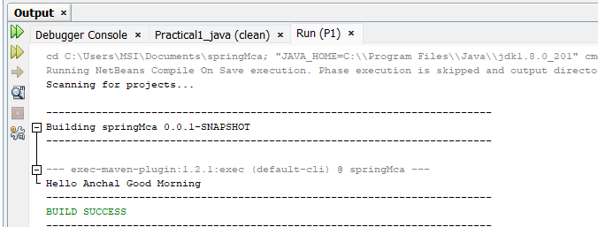

2. Write a Java program using Lambda Expression with single parameters.
Code:
package LambdaExpression;
interface Sayable {
public String say(String name);
}
public class P2 {
public static void main(String[] args) {
Sayable S1 = (name) -> {
return "Hello," + name;
};
System.out.println(S1.say("Anchal"));
Sayable S2 = (name) -> {
return "Anchal your " + name;
};
System.out.println(S2.say("Roll No is:119"));
}}
Output:
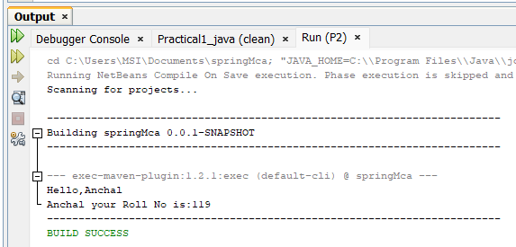

3. Write a Java program using Lambda Expression with multiple parameters to add two numbers.
Code:
package LambdaExpression;
interface Addition{
int add(int a, int b);
}
public class P3 {
public static void main(String[] args) {
Addition ad1=(a,b)->(a+b);
System.out.println("Addition is: "+ad1.add(119, 11));
Addition ad2=(int x,int y)->(x+y);
System.out.println("Addition is: "+ad2.add(123,400));
}}

Output:
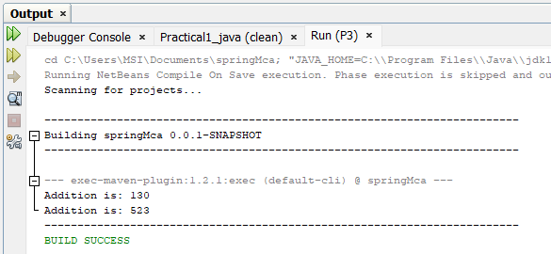

4. Write a Java program using Lambda Expression to calculate the following:
a. Convert Fahrenheit to Celcius
package LambdaExpression;
import java.util.Scanner;
class FahrenheittoCelsius
{
double celsius(double f)
{
return (f-32)*5/9;
}
public static void main(String arg[])
{
double a,c;
Scanner sc=new Scanner(System.in);
System.out.print("Enter Fahrenheit temperature: ");
a=sc.nextDouble();
FahrenheittoCelsius fah=new FahrenheittoCelsius( );
double result=fah.celsius(a);
System.out.println("Celsius temperature is = "+result);
}
}

Output:
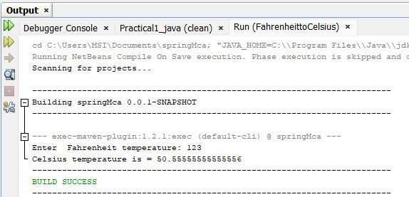

b. Convert Kilometers to Miles.
package LambdaExpression;
import java.util.Scanner;
public class KilometertoMiles {
public static void main(String[] args) {
double kilometers, miles;
double conversionFactor = 1.609344;
System.out.print("Enter distance value in kilometer:");
Scanner input = new Scanner(System.in);
kilometers = input.nextDouble();
miles = kilometers / conversionFactor;
System.out.println("The distance in Miles:" + miles);
}
}
Output:
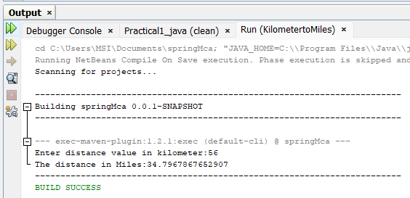

5. Write a Java program using Lambda Expression with or without return keyword.
Code:
package LambdaExpression;
import java.util.stream.LongStream;
public class P7 {
public static long factorialStreams(long n) {
return LongStream.rangeClosed(2, n).reduce(1, (long x, long y) -> x * y);
}
public static void main(String[] args) {
long n = 9;
long fact;
fact = factorialStreams(n);
System.out.println("The factorial of " + n + " is: " + fact);
}}
Output:
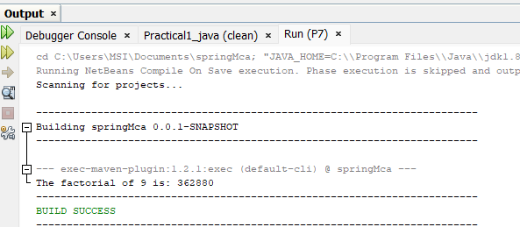

Practical 6

1. Create a Telephone directory using JSP and store all the information within a database, so that later could be retrieved as per the requirement. Make your own assumptions.

Code:
use 119_java_assignment3;
create table TELEPHONE( NAME varchar(100), mobileno int(10), city varchar(50));
desc telephone;
Index.html
<form action="indexaction.jsp" method="post">
<fieldset>
<label for="fname">Name:</label>
<input type="text" name="name"><br>
<label for="mobileno">Mobile Number:</label>
<input type="number" name="mobileno"><br>
<label for="city">city</label>
<input type="text" name="city"><br>
<input type="submit" value="submit">
</fieldset>
</form>

Indexacton.jsp
<%@ page import="java.sql.*" %>
<html>
<head>
<meta charset="UTF-8">
<title>Retrieve Data</title>
</head>
<body>
<h1>Retrieve Data</h1>
<table border="1">
<tr>
<th>Name</th>
<th>Mobile Number</th>
<th>City</th>
</tr>
<%
String name = request.getParameter("name");
String mobileno = request.getParameter("mobileno");
String city = request.getParameter("city");
try {
// Updated driver for modern MySQL
Class.forName("com.mysql.cj.jdbc.Driver");
Connection con = DriverManager.getConnection(
"jdbc:mysql://localhost:3306/119_java_assignment3?useSSL=false&serverTimezone=UTC",
"root",
"Vaibhav@9594"
);
// Use PreparedStatement for safe insert
String sqlInsert = "INSERT INTO TELEPHONE(name, mobileno, city) VALUES (?, ?, ?)";
PreparedStatement ps = con.prepareStatement(sqlInsert);
ps.setString(1, name);
ps.setString(2, mobileno);
ps.setString(3, city);
ps.executeUpdate();
// Retrieve all rows
Statement st = con.createStatement();
ResultSet rs = st.executeQuery("SELECT * FROM TELEPHONE");
while (rs.next()) {
%>
<tr>
<td><%= rs.getString("name") %></td>
<td><%= rs.getString("mobileno") %></td>
<td><%= rs.getString("city") %></td>
</tr>
<%
}
rs.close();
st.close();
ps.close();
con.close();
} catch(Exception e) {
e.printStackTrace();
}
%>
</table>
</body>
</html>

Output:
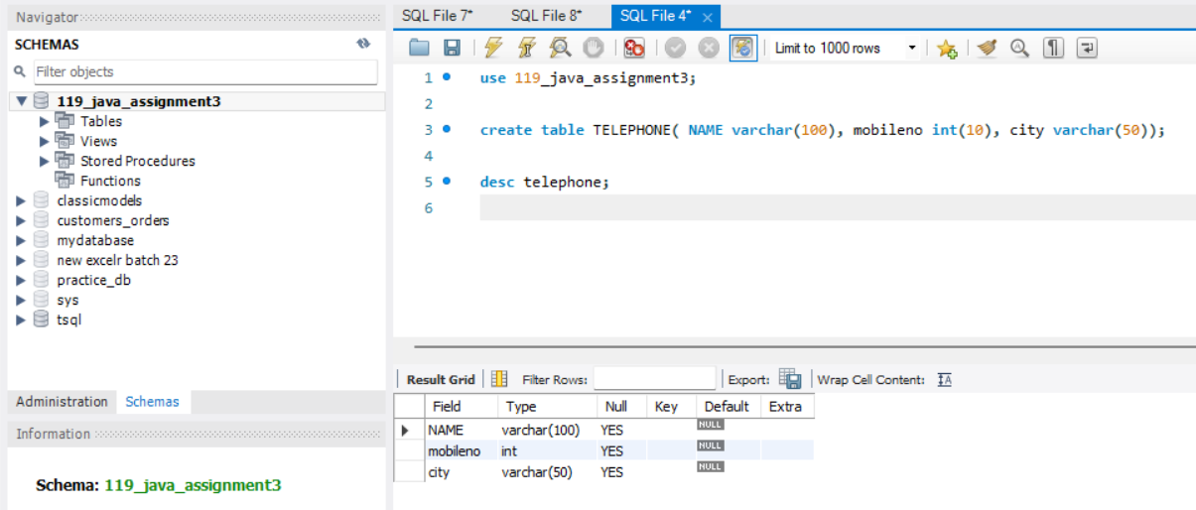

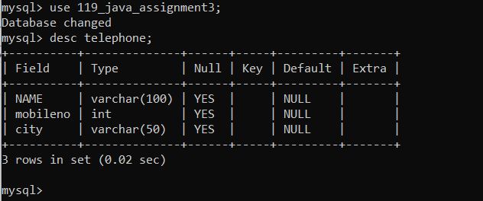

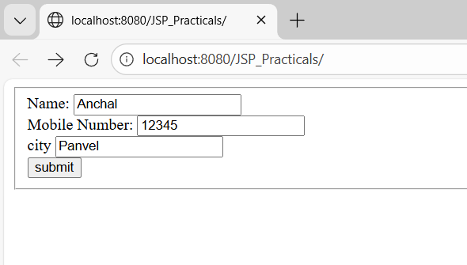

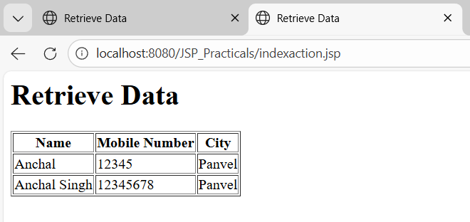

2. Write a JSP page to display the Registration form (Make your own assumptions)

Form.jsp
↓ (POST request)
person.jsp
↓
PersonBean (JavaBean)

jsp:useBean → creates or accesses bean
jsp:setProperty property="*" → auto maps form fields to bean setters
JavaBean must have:
private variables
public getters/setters
no-arg constructor

Create Package:
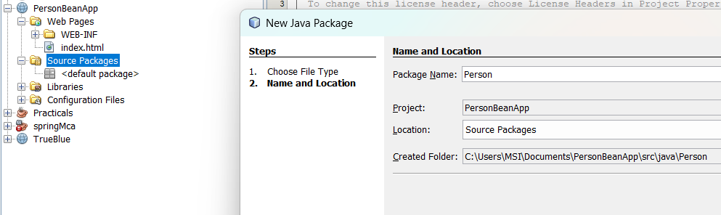
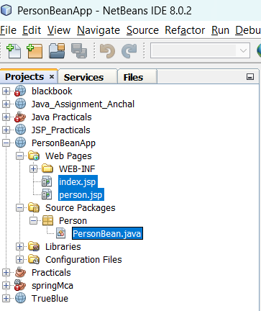
index.html
<%@ page language="java" contentType="text/html; charset=UTF-8"
pageEncoding="UTF-8"%>
<!DOCTYPE html>
<html>
<head>
<meta charset="UTF-8">
<title>Person Form</title>
</head>
<body>
<form method="post" action="person.jsp">
<h1>Person Form</h1>
First Name:
<input type="text" name="firstName"><br><br>
Last Name:
<input type="text" name="lastName"><br><br>
Email:
<input type="text" name="email"><br><br>
<button type="submit" name="submit">Submit</button>
</form></body></html>
person.jsp
<%@ page language="java" contentType="text/html; charset=UTF-8"
pageEncoding="UTF-8"%>
<!DOCTYPE html>
<html>
<head>
<meta charset="UTF-8">
<title>Person Bean Test</title>
</head>
<body>
<%
if ("POST".equalsIgnoreCase(request.getMethod())
&& request.getParameter("submit") != null) {
%>
<jsp:useBean id="PersonBean" class="Person.PersonBean" scope="session">
<jsp:setProperty name="PersonBean" property="*" />
</jsp:useBean>
First Name: <%= PersonBean.getFirstName() %><br>
Last Name: <%= PersonBean.getLastName() %><br>
Email: <%= PersonBean.getEmail() %><br>
<%
}
%></body></html>
PearsonBean.java
package Person;
public class PersonBean {
private String firstName;
private String lastName;
private String email;
public String getFirstName() {
return firstName;
}
public void setFirstName(String firstName) {
this.firstName = firstName;
}
public String getLastName() {
return lastName;}
public void setLastName(String lastName) {
this.lastName = lastName;}
public String getEmail() {
return email;}
public void setEmail(String email) {
this.email = email;
}}
Output:
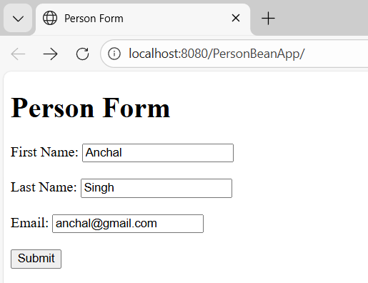

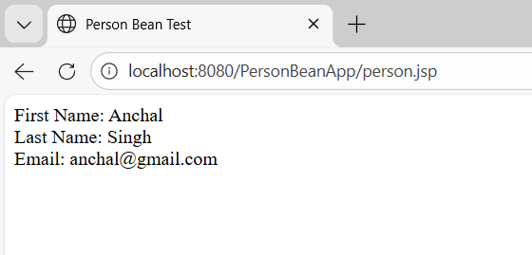

3. Write a JSP program to add, delete and display the records from StudentMaster (RollNo, Name, Semester, Course) table.

Db.jsp
<%@ page import="java.sql.*" %>
<%
Connection con = null;
String url = "jdbc:mysql://localhost:3306/119_java_assignment3?useSSL=false&serverTimezone=UTC";
String user = "root";
String password = "Vaibhav@9594";
try {
Class.forName("com.mysql.cj.jdbc.Driver");
con = DriverManager.getConnection(url, user, password);
} catch(Exception e) {
out.println("<h3>DB Connection Error: " + e.getMessage() + "</h3>");
}
%>

Index.jsp

<!DOCTYPE html>
<html>
<head>
<title>Student Management</title>
</head>
<body>
<h2>Add Student</h2>
<form action="addStudent.jsp" method="post">
Roll No: <input type="text" name="rollno" required><br><br>
Name: <input type="text" name="name" required><br><br>
Semester: <input type="text" name="semester" required><br><br>
Course: <input type="text" name="course" required><br><br>
<input type="submit" value="Add Student">
</form>
<hr>
<h2>Delete Student</h2>
<form action="deleteStudent.jsp" method="post">
Roll No: <input type="text" name="rollno" required><br><br>
<input type="submit" value="Delete Student">
</form>
<hr>

<a href="displayStudent.jsp">Display All Students</a>

</body>
</html>

addStudent.jsp

<%@ page import="java.sql.*" %>
<%@ include file="db.jsp" %>
<%
String rollStr = request.getParameter("rollno");
String name = request.getParameter("name");
String semesterStr = request.getParameter("semester");
String course = request.getParameter("course");

if (rollStr == null || semesterStr == null || rollStr.isEmpty() || semesterStr.isEmpty()) {
out.println("<h3>Error: Roll No or Semester cannot be empty</h3>");
out.println("<a href='index.jsp'>Go Back</a>");
if (con != null) con.close();
return;
}
int rollno = Integer.parseInt(rollStr);
int semester = Integer.parseInt(semesterStr);
PreparedStatement ps = null;
try {
ps = con.prepareStatement(
"INSERT INTO StudentMaster (RollNo, Name, Semester, Course) VALUES (?, ?, ?, ?)"
);
ps.setInt(1, rollno);
ps.setString(2, name);
ps.setInt(3, semester);
ps.setString(4, course);
ps.executeUpdate();
out.println("<h3>Student Added Successfully</h3>");
out.println("<a href='index.jsp'>Go Back</a>");
} catch (Exception e) {
out.println("<h3>Error: " + e.getMessage() + "</h3>");
} finally {
if (ps != null) ps.close();
if (con != null) con.close();
}
%>

deleteStudent.jsp

<%@ page import="java.sql.*" %>
<%@ include file="db.jsp" %>
<%
String rollStr = request.getParameter("rollno");
if (rollStr == null || rollStr.isEmpty()) {
out.println("<h3>Error: Roll No is required</h3>");
out.println("<a href='index.jsp'>Go Back</a>");
if (con != null) con.close();
return;
}
int rollno = Integer.parseInt(rollStr);
PreparedStatement ps = null;
try {
ps = con.prepareStatement(
"DELETE FROM StudentMaster WHERE RollNo = ?"
);
ps.setInt(1, rollno);
int rows = ps.executeUpdate();
if (rows > 0)
out.println("<h3>Student Deleted Successfully</h3>");
else
out.println("<h3>No student found with Roll No: " + rollno + "</h3>");

out.println("<a href='index.jsp'>Go Back</a>");

} catch (Exception e) {
out.println("<h3>Error: " + e.getMessage() + "</h3>");
} finally {
if (ps != null) ps.close();
if (con != null) con.close();
}
%>

displayStudent.jsp
<%@ page import="java.sql.*" %>
<%@ include file="db.jsp" %>
<!DOCTYPE html>
<html>
<head>
<title>All Students</title>
</head>
<body>
<h2>All Students</h2>
<%
PreparedStatement ps = null;
ResultSet rs = null;
try {
ps = con.prepareStatement("SELECT * FROM StudentMaster");
rs = ps.executeQuery();
%>
<table border="1" cellpadding="10">
<tr>
<th>Roll No</th>
<th>Name</th>
<th>Semester</th>
<th>Course</th>
</tr>
<%
while(rs.next()) {
%>
<tr>
<td><%= rs.getInt("RollNo") %></td>
<td><%= rs.getString("Name") %></td>
<td><%= rs.getInt("Semester") %></td>
<td><%= rs.getString("Course") %></td>
</tr>
<%
}
} catch(Exception e) {
out.println("<h3>Error: " + e.getMessage() + "</h3>");
} finally {
if(rs != null) rs.close();
if(ps != null) ps.close();
if(con != null) con.close();
}
%>
</table>
<br><br>
<a href="index.jsp">Back to Home</a>
</body>
</html>

Output:

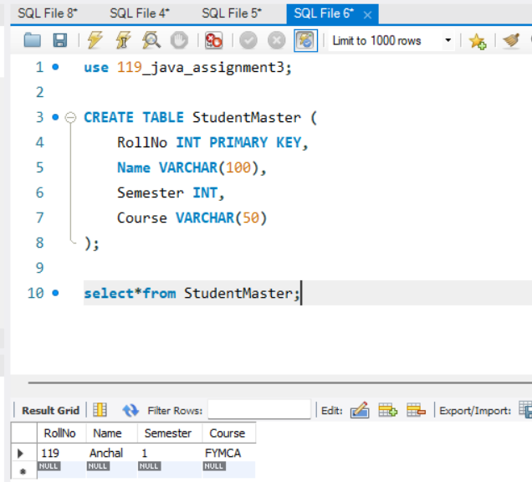
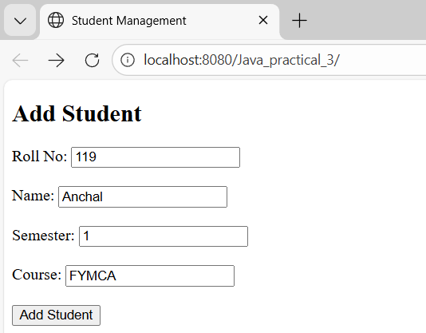

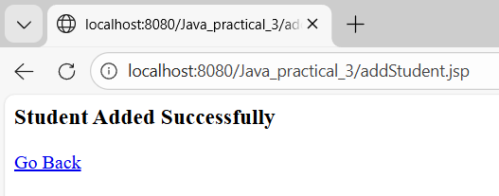

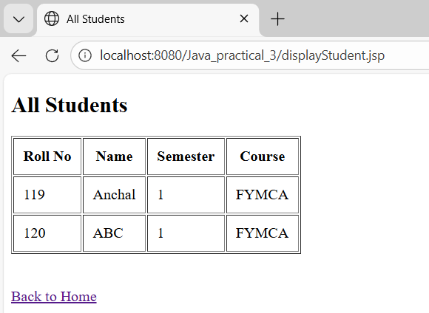

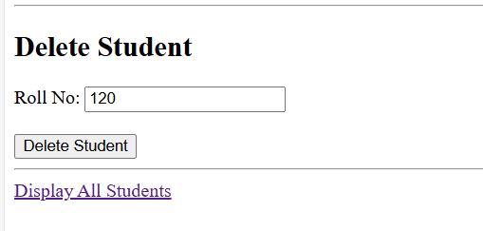

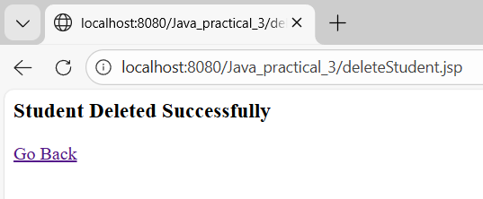

4. Design Loan calculator using JSP which accepts Period of Time (in years) and Principal Loan Amount. Display the payment amount for each loan and then list the loan balance and interest paid for each payment over the term of the loan for the following time period and interest rate:

a) 1 to 7 year at 5.35%

b) 8 to 15 year at 5.5%

c) 16 to 30 year at 5.75%

Code:

Index.jsp
<!DOCTYPE html>
<html>
<head>
<title>Loan Calculator</title>
</head>
<body>
<h2>Loan Calculator</h2>
<form action="loan_result.jsp" method="post">
<table>
<tr>
<td>Principal Amount:</td>
<td><input type="number" name="principal" required></td>
</tr>
<tr>
<td>Period (Years):</td>
<td><input type="number" name="years" required></td>
</tr>
<tr>
<td colspan="2" align="center">
<input type="submit" value="Calculate Loan">
</td>
</tr>
</table>
</form>

</body>
</html>

loan_result.jsp

<%@ page contentType="text/html; charset=UTF-8" pageEncoding="UTF-8" %>
<%@ page import="java.text.DecimalFormat" %>
<!DOCTYPE html> <html> <head>
<meta charset="UTF-8">
<title>Loan Details</title></head><body>
<h2>Loan Payment Details</h2> <%
double principal = Double.parseDouble(request.getParameter("principal"));
int years = Integer.parseInt(request.getParameter("years"));
double rate = 0;
// Interest rate selection
if(years >= 1 && years <= 7){
rate = 5.35;
}else if(years >= 8 && years <= 15){
rate = 5.50;
}else if(years >= 16 && years <= 30){
rate = 5.75;
}else{
out.println("Invalid loan period");
Return; }
int months = years * 12;
double monthlyRate = rate / (12 * 100);
// EMI formula
double emi = (principal * monthlyRate * Math.pow(1 + monthlyRate, months)) /
(Math.pow(1 + monthlyRate, months) - 1);
DecimalFormat df = new DecimalFormat("0.00");
double balance = principal; %>
<b>Principal:</b> ₹<%= df.format(principal) %><br>
<b>Years:</b> <%= years %><br>
<b>Interest Rate:</b> <%= rate %>%<br>
<b>Monthly EMI:</b> ₹<%= df.format(emi) %><br><br>
<table border="1"> <tr>
<th>Payment No</th> <th>EMI</th> <th>Interest Paid</th>
<th>Balance</th> </tr><%
for(int i=1; i<=months; i++){
double interest = balance * monthlyRate;
double principalPaid = emi - interest;
balance -= principalPaid; %> <tr>
<td><%= i %></td>
<td>₹<%= df.format(emi) %></td>
<td>₹<%= df.format(interest) %></td>
<td>₹<%= df.format(balance < 0 ? 0 : balance) %></td>
</tr><%
} %>
</table></body><html>

Output:
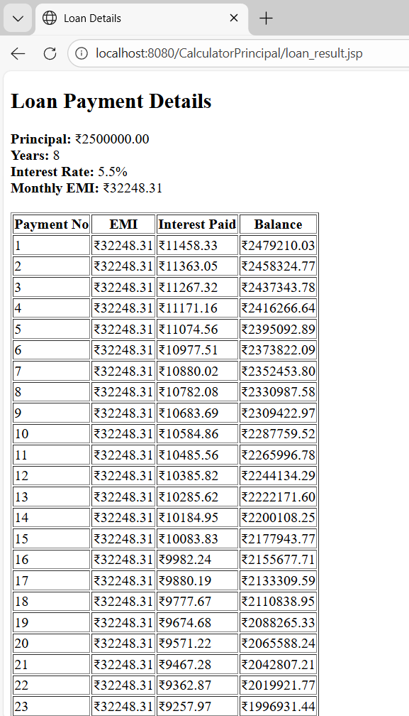

5. Write a program using JSP that displays a webpage consisting of Application form for change of Study Center which can be filled by any student who wants to change his/ her study center. Make necessary assumptions.
Code:
create table Reg(first_name varchar(25),last_name varchar(25),username varchar(30), password varchar(15), address varchar(40), contact int(10));
desc Reg;
Registrationform.html
<h1>Registration Form</h1>
<form action="regaction.jsp" method="post">
<fieldset>
<table><tr>
<td>First Name</td>
<td><input type="text" name="first_name" /></td></tr><tr>
<td>Last Name</td>
<td><input type="text" name="last_name" /></td>
</tr><tr>
<td>Username</td>
<td><input type="text" name="username" /></td>
</tr><tr>
<td>Password</td>
<td><input type="password" name="password" /></td>
</tr><tr>
<td>Address</td>
<td><input type="text" name="address" /></td>
</tr><tr>
<td>Contact No</td>
<td><input type="text" name="contact" /></td>
</tr></table><br>
<input type="submit" value="Submit" />
</fieldset>
</form>
regaction.jsp
<%@ page import="java.sql.*" %>
<html>
<head>
<meta charset="UTF-8">
<title>Retrieve Data</title>
</head><body>
<h1>User Info</h1>
<table border="1">
<tr>
<th>First Name</th>
<th>Last Name</th>
<th>Username</th>
<th>Address</th>
<th>Contact no</th> </tr>
<%
String first_name = request.getParameter("first_name");
String last_name = request.getParameter("last_name");
String username = request.getParameter("username");
String password = request.getParameter("password");
String address = request.getParameter("address");
String contact = request.getParameter("contact");
try {
Class.forName("com.mysql.cj.jdbc.Driver"); // updated driver
Connection con = DriverManager.getConnection(
"jdbc:mysql://localhost:3306/119_java_assignment3?useSSL=false&serverTimezone=UTC",
"root",
"Vaibhav@9594"
);
// Use PreparedStatement for safer inserts
String sqlInsert = "INSERT INTO Reg(first_name, last_name, username, password, address, contact) VALUES (?, ?, ?, ?, ?, ?)";
PreparedStatement ps = con.prepareStatement(sqlInsert);
ps.setString(1, first_name);
ps.setString(2, last_name);
ps.setString(3, username);
ps.setString(4, password);
ps.setString(5, address);
ps.setString(6, contact);
ps.executeUpdate();
// Retrieve and display all rows
Statement st = con.createStatement();
ResultSet rs = st.executeQuery("SELECT * FROM Reg");
while (rs.next()) {
%>
<tr>
<td><%= rs.getString("first_name") %></td>
<td><%= rs.getString("last_name") %></td>
<td><%= rs.getString("username") %></td>
<td><%= rs.getString("address") %></td>
<td><%= rs.getString("contact") %></td>
</tr>
<%
}
rs.close();
st.close();
ps.close();
con.close();
} catch (Exception e) {
e.printStackTrace();
}
%>
</table></body></html>

Output:
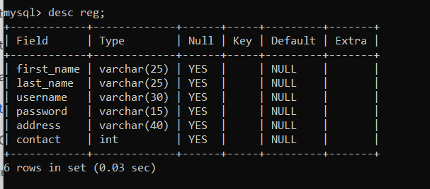
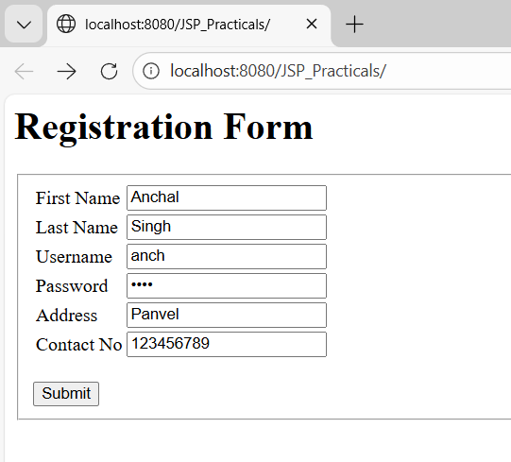

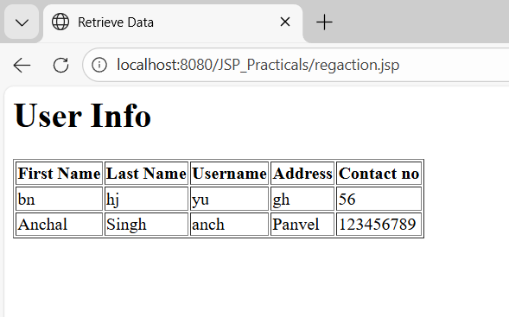

6. Write a JSP program that demonstrates the use of JSP declaration, scriptlet, directives, expression, header and footer.
action_tags.jsp
<%@ page language="java" contentType="text/html; charset=ISO-8859-1" pageEncoding="ISO-8859-1"%>
<!DOCTYPE html>
<html>
<head>
<meta charset="UTF-8">
<title>action tag</title>
</head>
<body>
<h1>JSP Action Tags Demonstration</h1>
<!--jsp:include action tag -->
<h3>Use of include action tags</h3>
<jsp:include page="header.jsp" />

<!--jsp:useBean action tag -->
<h3>Use of useBean action tags</h3>
<jsp:useBean id="date" class="java.util.Date" /> Current Date: <%= date %><br><br>
</body>
</html>

header.jsp

<%@ page language="java" contentType="text/html; charset=ISO-8859-1"
pageEncoding="ISO-8859-1"%>
<!DOCTYPE html>
<html>
<head>
<meta charset="UTF-8">

<title>document</title>
</head>
<body>
<h2>Header Page</h2>
<p>This is a header page that can be included in multiple pages using the jsp:include action tag.</p>
</body>
</html>

Output:
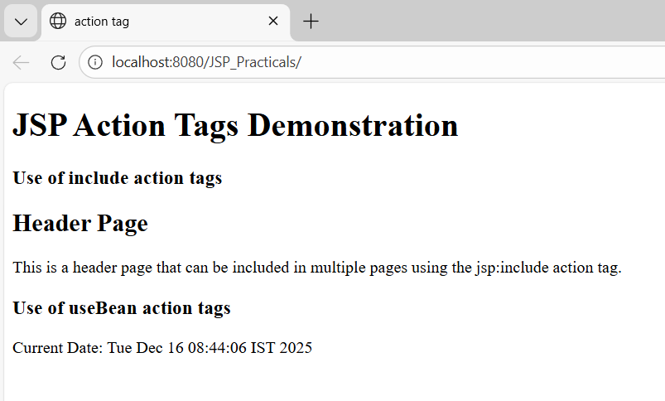
Forward Action Tag
<%@ page language="java" contentType="text/html; charset=ISO-8859-1"
pageEncoding="ISO-8859-1"%>
<!DOCTYPE html>
<html><head>
<meta charset="UTF-8">
<title>forward tag</title>
</head><body>
<h1>JSP Action Tags Demonstration</h1>
<!--jsp:forward action tag -->
<h3>Use of forward action tags</h3>
<jsp:forward page="forwardPage.jsp" />
</body></html>

forwardPage.jsp

<%@ page language="java" contentType="text/html; charset=ISO-8859-1"
pageEncoding="ISO-8859-1"%>
<!DOCTYPE html>
<html><head>
<meta charset="UTF-8">
<title>Insert title here</title>
</head><body>
<h2>Forward Page</h2>
<p>This is a page that can be forwarded to using the jsp:forward action tag.</p>
<p>Anchal Singh 119</p>
</body></html>

Output:

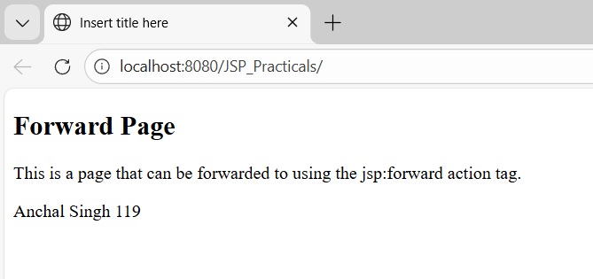

Practical 7

1. Write a program to print “Hello World” using spring framework.
Pom.xml
<?xml version="1.0" encoding="UTF-8"?>
<!--project xmlns="http://maven.apache.org/POM/4.0.0" xmlns:xsi="http://www.w3.org/2001/XMLSchema-instance" xsi:schemaLocation="http://maven.apache.org/POM/4.0.0 http://maven.apache.org/xsd/maven-4.0.0.xsd"-->
<project xmlns="http://maven.apache.org/POM/4.0.0"
xmlns:xsi="http://www.w3.org/2001/XMLSchema-instance"
xsi:schemaLocation="http://maven.apache.org/POM/4.0.0
http://maven.apache.org/xsd/maven-4.0.0.xsd">
<modelVersion>4.0.0</modelVersion>
<groupId>com.springMca</groupId>
<artifactId>springMca</artifactId>
<version>0.0.1-SNAPSHOT</version>
<dependencies>
<!-- Spring Context -->
<dependency>
<groupId>org.springframework</groupId>
<artifactId>spring-context</artifactId>
<version>5.2.3.RELEASE</version>
</dependency>

<!-- Spring AOP -->
<dependency>
<groupId>org.springframework</groupId>
<artifactId>spring-aop</artifactId>
<version>5.2.3.RELEASE</version>
</dependency>
<!-- AspectJ Runtime (REQUIRED for @Aspect, @Before) -->
<dependency>
<groupId>org.aspectj</groupId>
<artifactId>aspectjrt</artifactId>
<version>1.9.7</version>
</dependency>
<!-- AspectJ Weaver -->
<dependency>
<groupId>org.aspectj</groupId>
<artifactId>aspectjweaver</artifactId>
<version>1.9.6</version>
</dependency>
</dependencies>
<properties>
<maven.compiler.source>1.8</maven.compiler.source>
<maven.compiler.target>1.8</maven.compiler.target>
</properties> </project>
HelloWorld.java
package newpackage;
public class HelloWorld {
private String message;
public void setMessage(String message) {
this.message = message; }
public void printMessage() {
System.out.println(message); }}
Main.java
package newpackage;
import org.springframework.context.ApplicationContext;
import org.springframework.context.support.ClassPathXmlApplicationContext;
public class Main {
public static void main(String[] args) {
ApplicationContext context =
new ClassPathXmlApplicationContext("applicationContext.xml");
HelloWorld obj = (HelloWorld) context.getBean("helloBean");
obj.printMessage();}}
Applicationcontext.xml
<?xml version="1.0" encoding="UTF-8"?>
<beans xmlns="http://www.springframework.org/schema/beans"
xmlns:xsi="http://www.w3.org/2001/XMLSchema-instance" xsi:schemaLocation="
http://www.springframework.org/schema/beans
https://www.springframework.org/schema/beans/spring-beans.xsd">
<bean id="helloBean" class="newpackage.HelloWorld">
<property name="message" value="Hello World from Anchal Singh 119" /> </bean></beans>
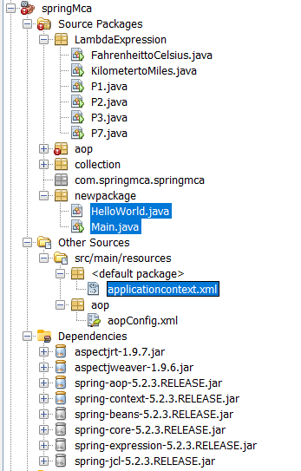
Spring
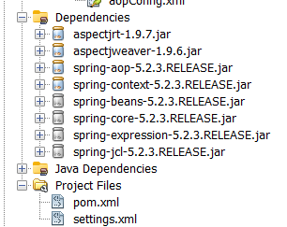

Output:
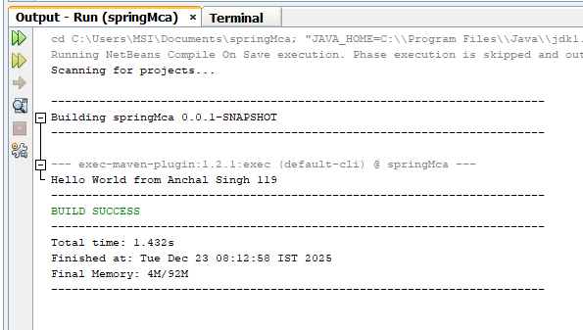

2. Write a program to demonstrate dependency injection via setter method

Main.java

package newpackage;
import org.springframework.context.ApplicationContext;
import org.springframework.context.support.ClassPathXmlApplicationContext;
public class Main{
public static void main(String[] args) {

ApplicationContext context =
new ClassPathXmlApplicationContext("applicationcontext.xml");

MessagePrinter printer = (MessagePrinter) context.getBean("messagePrinter");
printer.printMessage();
}
}

MessageService.java

package newpackage;
public class MessageService {
public String getMessage() {
return "Hello from MessageService and Anchal 119!";
}
}

MessagePrinter.java

package newpackage;
public class MessagePrinter {
private MessageService messageService;
// Setter method for dependency injection
public void setMessageService(MessageService messageService) {
this.messageService = messageService;
}
// Uses the injected dependency
public void printMessage() {
System.out.println(messageService.getMessage());
}
}

applicationcontext.xml

<?xml version="1.0" encoding="UTF-8"?>
<beans xmlns="http://www.springframework.org/schema/beans"
xmlns:xsi="http://www.w3.org/2001/XMLSchema-instance"
xsi:schemaLocation="
http://www.springframework.org/schema/beans
https://www.springframework.org/schema/beans/spring-beans.xsd">
<!-- Dependency bean -->
<bean id="messageService" class="newpackage.MessageService" />
<!-- Consumer bean using setter injection -->
<bean id="messagePrinter" class="newpackage.MessagePrinter">
<property name="messageService" ref="messageService" />
</bean>

</beans>

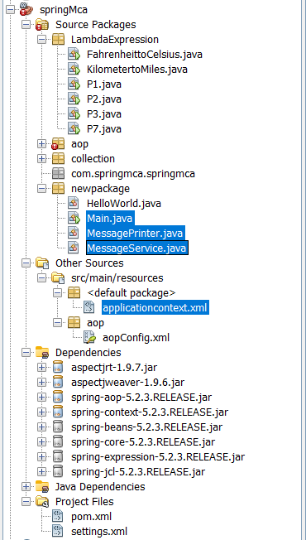

Output:

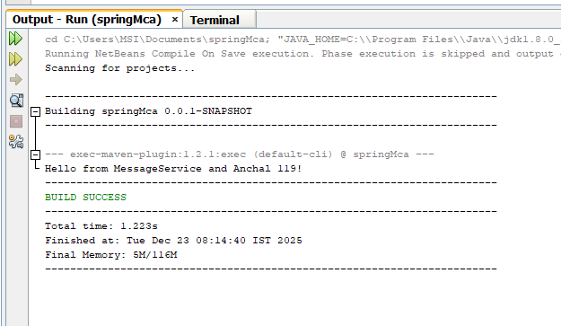

3. Write a program to demonstrate dependency injection via Constructor.
Main.java

package newpackage;
import org.springframework.context.ApplicationContext;
import org.springframework.context.support.ClassPathXmlApplicationContext;
public class Main {

public static void main(String[] args) {
ApplicationContext context =
new ClassPathXmlApplicationContext("applicationcontext.xml");
MessagePrinter printer = (MessagePrinter) context.getBean("messagePrinter");
printer.printMessage();
}
}

Applicationcontext.xml
<?xml version="1.0" encoding="UTF-8"?>
<beans xmlns="http://www.springframework.org/schema/beans"
xmlns:xsi="http://www.w3.org/2001/XMLSchema-instance"
xsi:schemaLocation="
http://www.springframework.org/schema/beans
https://www.springframework.org/schema/beans/spring-beans.xsd">

<!-- Dependency Bean -->
<bean id="messageService" class="newpackage.MessageService" />

<!-- Constructor Injection -->
<bean id="messagePrinter" class="newpackage.MessagePrinter">
<constructor-arg ref="messageService" />
</bean>

</beans>

MessageService.java

package newpackage;
public class MessageService {
public String getMessage() {
return "Hello from MessageService (Constructor Injection) and Anchal 119!";
}
}

MessagePrinter.java

package newpackage;
public class MessagePrinter {

private MessageService messageService;

// Constructor for Dependency Injection
public MessagePrinter(MessageService messageService) {
this.messageService = messageService;
}

public void printMessage() {
System.out.println(messageService.getMessage());
}
}

Output:
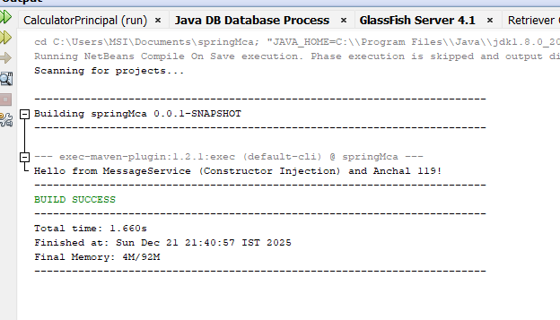

4. Write a program to demonstrate Autowiring.

Main.java

package newpackage;
import org.springframework.context.ApplicationContext;
import org.springframework.context.support.ClassPathXmlApplicationContext;
public class Main {
public static void main(String[] args) {
ApplicationContext context =
new ClassPathXmlApplicationContext("applicationcontext.xml");
MessagePrinter printer = context.getBean(MessagePrinter.class);
printer.printMessage();
}
}

MessageService.java

package newpackage;
import org.springframework.stereotype.Component;
@Component
public class MessageService {
public String getMessage() {
return "Hello from MessageService (Autowiring) and Anchal 119!";}}

MessagePrinter.java

package newpackage;
import org.springframework.beans.factory.annotation.Autowired;
import org.springframework.stereotype.Component;

@Component
public class MessagePrinter {

@Autowired
private MessageService messageService; // automatically injected

public void printMessage() {
System.out.println(messageService.getMessage());
}
}

applicationcontext.xml

<?xml version="1.0" encoding="UTF-8"?>
<beans xmlns="http://www.springframework.org/schema/beans"
xmlns:xsi="http://www.w3.org/2001/XMLSchema-instance"
xmlns:context="http://www.springframework.org/schema/context"
xsi:schemaLocation="
http://www.springframework.org/schema/beans
https://www.springframework.org/schema/beans/spring-beans.xsd
http://www.springframework.org/schema/context
https://www.springframework.org/schema/context/spring-context.xsd">

<!-- Enables @Autowired and @Component scanning -->
<context:component-scan base-package="newpackage" />

</beans>

Output:
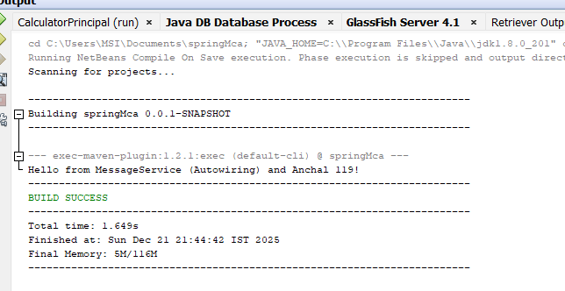

Practical 8

Write aprogramtodemonstrateSpringAOP –before advice.

File → New Project
Select Maven → Java Application
Click Next
Fill details:
- Project Name: springMca
- Group Id: com.springMca
- Version: 0.0.1-SNAPSHOT
Source Packages → New → Java Package → Name: aop
Pom.xml
<?xml version="1.0" encoding="UTF-8"?>

<!--project xmlns="http://maven.apache.org/POM/4.0.0" xmlns:xsi="http://www.w3.org/2001/XMLSchema-instance" xsi:schemaLocation="http://maven.apache.org/POM/4.0.0 http://maven.apache.org/xsd/maven-4.0.0.xsd"-->
<project xmlns="http://maven.apache.org/POM/4.0.0"
xmlns:xsi="http://www.w3.org/2001/XMLSchema-instance"
xsi:schemaLocation="http://maven.apache.org/POM/4.0.0
http://maven.apache.org/xsd/maven-4.0.0.xsd">

<modelVersion>4.0.0</modelVersion>

<groupId>com.springMca</groupId>
<artifactId>springMca</artifactId>
<version>0.0.1-SNAPSHOT</version>

<dependencies>

<!-- Spring Context -->
<dependency>
<groupId>org.springframework</groupId>
<artifactId>spring-context</artifactId>
<version>5.2.3.RELEASE</version>
</dependency>

<!-- Spring AOP -->
<dependency>
<groupId>org.springframework</groupId>
<artifactId>spring-aop</artifactId>
<version>5.2.3.RELEASE</version>
</dependency>

<!-- AspectJ Runtime (REQUIRED for @Aspect, @Before) -->
<dependency>
<groupId>org.aspectj</groupId>
<artifactId>aspectjrt</artifactId>
<version>1.9.7</version>
</dependency>

<!-- AspectJ Weaver -->
<dependency>
<groupId>org.aspectj</groupId>
<artifactId>aspectjweaver</artifactId>
<version>1.9.6</version>
</dependency>

</dependencies>

</project>

Interface
Source Packages → aop → New → Java Interface

Guitar.java
package aop;
public interface Guitar {
public void makeSong();
}

TargetObject

Source Packages → aop → New → Java Class
brook.java

package aop;

import aop.Guitar;
public class brook implements Guitar {
public void makeSong() {
System.out.println("Song Started");
System.out.println("Song Ended");
}
}

AspectClass

Source Packages → aop → New → Java Class

mcaAspect.java

package aop;
import static com.sun.xml.internal.ws.dump.LoggingDumpTube.Position.Before;
import org.aspectj.lang.annotation.Aspect;
import org.aspectj.lang.annotation.Before;

@Aspect
public class mcaAspect {

@Before("execution(* aop.brook.makeSong())")
public void beforeSong() {
System.out.println("YahooYahoo:IambeforeAspect");
}
}
ConfigurationClass
<?xmlversion="1.0"encoding="UTF-8"?>
<beans xmlns="http://www.springframework.orgschema/beans"xmlns:xsi="http://www.w3.org/2001/XMLSchema-instance"xmlns:context="http://www.springframework.org/schema/context"xmlns:aop="http://www.springframework.org/schema/aop"
xsi:schemaLocation="http://www.springframework.org/schema/beanshttp://www.springframework.org/schema/beans/spring-beans.xsdhttp://www.springframework.org/schema/aophttp://www.springframework.org/schema/aop/spring-aop.xsd">

<aop:aspectj-autoproxy/>

<beanname="brook"class="aop.brook"/>
<beanname="mcaaspect"class="aop.mcaAspect"/>

</beans>

Settings.xml

<settings xmlns="http://maven.apache.org/SETTINGS/1.0.0"
xmlns:xsi="http://www.w3.org/2001/XMLSchema-instance"
xsi:schemaLocation="http://maven.apache.org/SETTINGS/1.0.0
https://maven.apache.org/xsd/settings-1.0.0.xsd">
<mirrors>
<mirror>
<id>central</id>
<mirrorOf>central</mirrorOf>
<url>https://repo.maven.apache.org/maven2</url>
</mirror>
</mirrors>

</settings>

MainClass - App.java

package aop;

import org.springframework.context.ApplicationContext;
import org.springframework.context.support.ClassPathXmlApplicationContext;

public class App {

public static void main(String[] args) {
ApplicationContext context =
new ClassPathXmlApplicationContext("aop/aopConfig.xml");

Guitar temp = (Guitar) context.getBean("brook");
temp.makeSong();
}
}
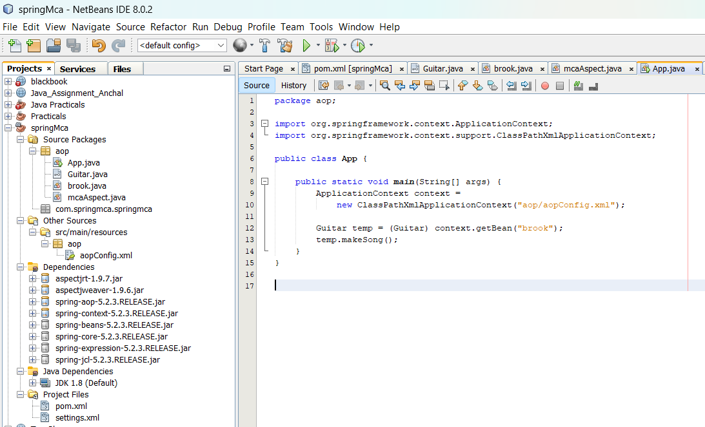
Output:
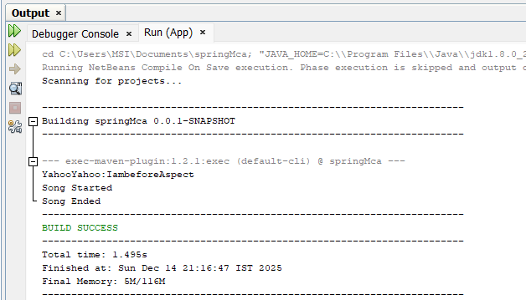

Write a program to demonstrate SpringAOP–after advice.

AspectClass

package aop;

import org.aspectj.lang.annotation.After;
import org.aspectj.lang.annotation.Aspect;

@Aspect
public class mcaAspect {

@After("execution(* aop.brook.makeSong())")
public void afterSong() {
System.out.println("YahooYahoo:IamAfterAspect_119");
}
}

Output:
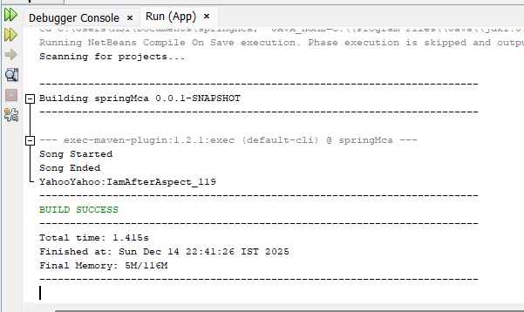

Write a program to demonstrate Spring AOP– around advice.

AspectClass
package aop;

import org.aspectj.lang.ProceedingJoinPoint;
import org.aspectj.lang.annotation.Around;
import org.aspectj.lang.annotation.Aspect;

@Aspect
public class mcaAspect {

@Around("execution(* aop.brook.makeSong())")
public Object aroundSong(ProceedingJoinPoint joinPoint) throws Throwable {
System.out.println("YahooYahoo: Around Before Song");

// Proceed with the original method
Object result = joinPoint.proceed();

System.out.println("YahooYahoo: Around After Song_119");

return result;
}
}

Output:
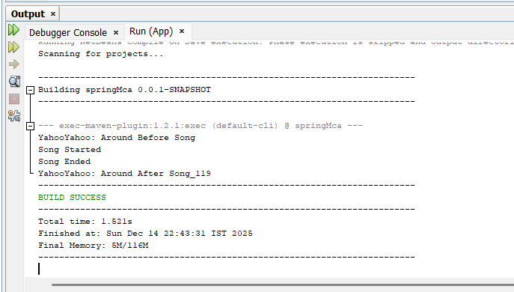

Write a program to demonstrateSpringAOP–after returning advice.

AspectClass

package aop;

import org.aspectj.lang.annotation.AfterReturning;
import org.aspectj.lang.annotation.Aspect;

@Aspect
public class mcaAspect {

@AfterReturning("execution(* brook.makeSong())")
public void afterReturnSong() {
System.out.println("YahooYahoo: AfterReturning Aspect_119");
}
}

Output:
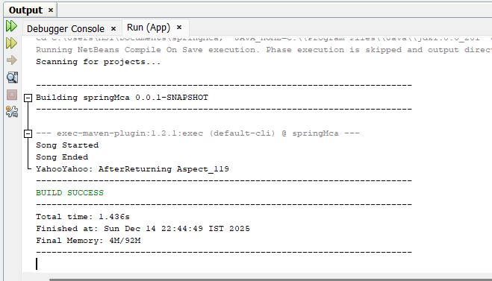

Write a program to demonstrateSpringAOP –afterthrowing advice.

AspectClass
package aop;
import org.aspectj.lang.annotation.AfterThrowing;
import org.aspectj.lang.annotation.Aspect;
import org.aspectj.lang.annotation.Pointcut;
@Aspect
public class mcaAspect {
// Pointcut for makeSong() method in brook class
@Pointcut("execution(* brook.makeSong(..))")
private void selectAll() {}
// After throwing advice
@AfterThrowing(pointcut = "selectAll()", throwing = "error")
public void afterThrowingAdvice(IllegalArgumentException error) {
System.out.println("YahooYahoo: There has been an exception: " + error.getMessage());
}
}

TargetClass
package aop;

public class brook implements Guitar {

@Override
public void makeSong() {
System.out.println("Song Started");
System.out.println("Song Ended");
throw new IllegalArgumentException("An error occurred while making the song.");
}
}

Output:
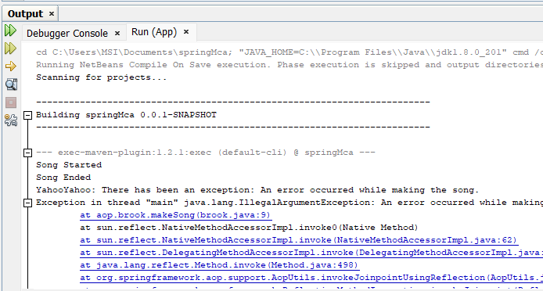

Write a program to demonstrate SpringAOP – pointcuts.

AspectClass
package aop;

import org.aspectj.lang.annotation.AfterReturning;
import org.aspectj.lang.annotation.Aspect;
import org.aspectj.lang.annotation.Pointcut;

@Aspect
public class mcaAspect {

// Define pointcut
@Pointcut("execution(* aop.brook.makeSong())")
public void songPointCut() {
// Pointcut methods should have empty body
}

// Advice that uses the pointcut
@AfterReturning("songPointCut()")
public void afterSong() {
System.out.println("YahooYahoo: Used BY Pointcut_119");
}
}

Brook.java
package aop;
public class brook implements Guitar {
public void makeSong() {
System.out.println("Song Started");
System.out.println("Song Ended");
}
}

Output:

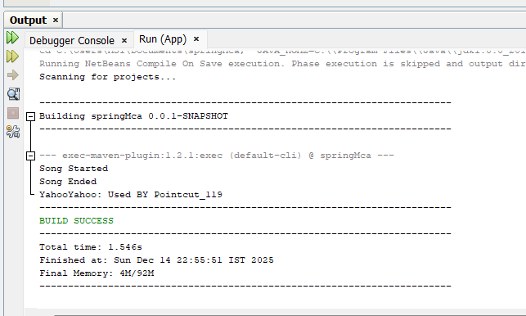

Practical 9

Assignment based Spring JDBC

Write a program to insert, update and delete records from the given table.

Code:

Student.java
package newpackage;
public class Student {
private int id;
private String name;
private int age;
// parameterized constructor
public Student(int id, String name, int age)
{
this.id = id;
this.name = name;
this.age = age;
}
// getters and setters
public int getId()
{
return id;
}
public void setId(int id)
{

this.id = id;
}
public String getName()
{
return name;
}
public void setName(String name)
{
this.name = name;
}
public int getAge()
{
return age;
}
public void setAge(int age)
{
this.age = age;
}
// a method to display data
public void show()
{
System.out.println("Id = " + id + ", Name = " + name + ", Age = " + age ); } }

StudentDao.java

package newpackage;
import newpackage.Student;
public interface StudentDao {
public int save(Student s) throws Exception;
public int update(Student s) throws Exception;
public int delete(int id) throws Exception;
}

Studentdaoimpl.java

package newpackage;
import java.sql.Connection;
import java.sql.PreparedStatement;
import javax.sql.DataSource;
import newpackage.StudentDao;
import newpackage.Student;
import org.springframework.jdbc.core.JdbcTemplate;
import javax.sql.DataSource;
public class Studentdaoimpl implements newpackage.StudentDao {
private DataSource ds;
private Connection con;
public void setDs(DataSource ds)
{
this.ds = ds;
}
@Override
public int save(newpackage.Student s) throws Exception
{
con = ds.getConnection();
String sql = "insert into student1 values(?,?,?)";
PreparedStatement ps = con.prepareStatement(sql); ps.setInt(1, s.getId());
ps.setString(2, s.getName());
ps.setInt(3, s.getAge());
return ps.executeUpdate();
}
@Override
public int update(newpackage.Student s) throws Exception
{
con = ds.getConnection();
String sql = "update student1 set name=?, age=? where id=?";
PreparedStatement ps = con.prepareStatement(sql);
ps.setString(1, s.getName());
ps.setInt(2, s.getAge());
ps.setInt(3, s.getId());
return ps.executeUpdate();
}
@Override
public int delete(int id) throws Exception
{
con = ds.getConnection();
String sql = "delete from student where id=?";
PreparedStatement ps = con.prepareStatement(sql);
ps.setInt(1, id);
return ps.executeUpdate();
}
}

Appconfig.xml

<?xml version="1.0" encoding="UTF-8"?>
<beans xmlns="http://www.springframework.org/schema/beans"
xmlns:xsi="http://www.w3.org/2001/XMLSchema-instance"
xsi:schemaLocation="
http://www.springframework.org/schema/beans
http://www.springframework.org/schema/beans/spring-beans.xsd">
<bean id="bds"
class="org.springframework.jdbc.datasource.DriverManagerDataSource">
<property name="driverClassName" value="com.mysql.cj.jdbc.Driver" />
<property name="url" value="jdbc:mysql://localhost:3306/WT_Practical_119" />
<property name="username" value="root" />
<property name="password" value="Vaibhav@9594" />
</bean>
<bean id="dao" class="newpackage.Studentdaoimpl">
<property name="ds" ref="bds" />
</bean> </beans>

Main.java

package newpackage;
import org.springframework.context.ApplicationContext;
import org.springframework.context.support.ClassPathXmlApplicationContext;
import newpackage.StudentDao;
import newpackage.Studentdaoimpl;
import newpackage.Student;
public class Main {
public static void main(String[] args) throws Exception {
// Loading bean configuration file
ApplicationContext ac = new ClassPathXmlApplicationContext("Appconfig.xml");
StudentDao dao = (Studentdaoimpl)ac.getBean("dao");
// Creating Student object
Student s1 = new Student(122, "Anchal", 21);
Student s2 = new Student(123, "Singh", 22);
Student s3 = new Student(124, "John", 23);
// Saving Student obj in db
int check1 = dao.save(s1);
int check2 = dao.save(s2);
int check3 = dao.save(s3);
System.out.println("\nChecking if inserted?");
System.out.println((check1>0) ? "1st Record Inserted" : "1st Record Not Inserted"); System.out.println((check2>0) ? "2nd Record Inserted" : "2nd Record Not Inserted"); System.out.println((check3>0) ? "3rd Record Inserted" : "3rd Record Not Inserted"); s1.setName("Ajit Gupta");
s2.setName("Anchal Singh");
s3.setName("Paul");
int update1 = dao.update(s1);
int update2 = dao.update(s2);
int update3 = dao.update(s3);
System.out.println("\nChecking if updated?");
System.out.println((update1>0) ? "1st Record Updated" : "1st Record Not Updated"); System.out.println((update2>0) ? "2nd Record Updated" : "2nd Record Not Updated"); System.out.println((update3>0) ? "3rd Record Updated" : "3rd Record Not Updated"); int delete1 = dao.delete(45);
int delete2 = dao.delete(45);

System.out.println("\nChecking if deleted?");
System.out.println((delete1>0) ? "1st Record Deleted" : "1st Record Not Deleted"); System.out.println((delete2>0) ? "2nd Record Deleted" : "2nd Record Not Deleted"); } }

Pom.xml
For jdbc dependency
<?xml version="1.0" encoding="UTF-8"?>
<!--project xmlns="http://maven.apache.org/POM/4.0.0" xmlns:xsi="http://www.w3.org/2001/XMLSchema-instance" xsi:schemaLocation="http://maven.apache.org/POM/4.0.0 http://maven.apache.org/xsd/maven-4.0.0.xsd"-->
<project xmlns="http://maven.apache.org/POM/4.0.0"
xmlns:xsi="http://www.w3.org/2001/XMLSchema-instance"
xsi:schemaLocation="http://maven.apache.org/POM/4.0.0
http://maven.apache.org/xsd/maven-4.0.0.xsd">
<modelVersion>4.0.0</modelVersion>
<groupId>com.springMca</groupId>
<artifactId>springMca</artifactId>
<version>0.0.1-SNAPSHOT</version>
<dependencies>
<!-- Spring Context -->
<dependency>
<groupId>org.springframework</groupId>
<artifactId>spring-context</artifactId>
<version>5.3.30</version>
</dependency>
<!-- Spring JDBC -->
<dependency>
<groupId>org.springframework</groupId>
<artifactId>spring-jdbc</artifactId>
<version>5.3.30</version>
</dependency>
<!-- MySQL Connector -->
<dependency>
<groupId>mysql</groupId>
<artifactId>mysql-connector-java</artifactId>
<version>8.0.33</version>
</dependency>
<!-- AspectJ (Optional if you plan AOP later) -->
<dependency>
<groupId>org.aspectj</groupId>
<artifactId>aspectjrt</artifactId>
<version>1.9.7</version>
</dependency><dependency>
<groupId>org.aspectj</groupId>
<artifactId>aspectjweaver</artifactId>
<version>1.9.6</version>
</dependency></dependencies><properties>
<maven.compiler.source>1.8</maven.compiler.source>
<maven.compiler.target>1.8</maven.compiler.target>
</properties></project>

Output:
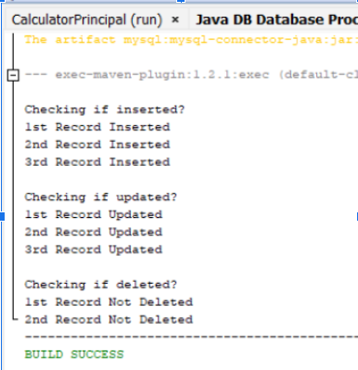
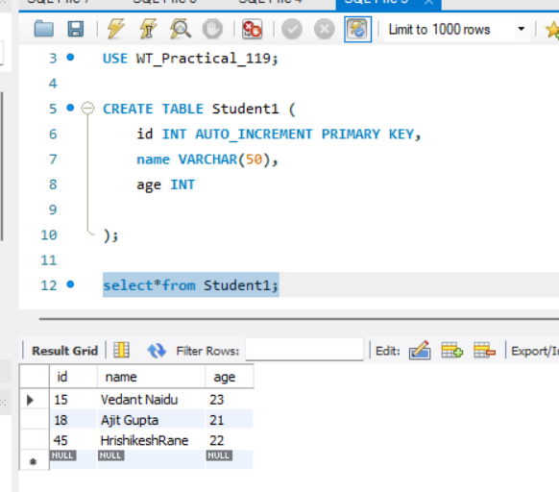
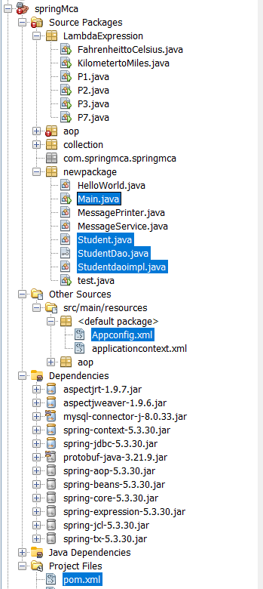

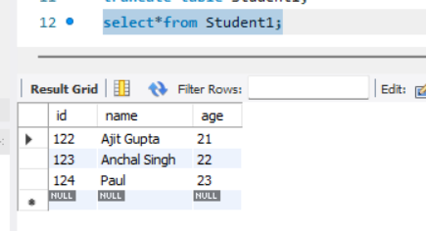

Write a program to demonstrate Prepared Statement in Spring JdbcTemplate.
Employee.java
package newpackage;
public class Employee {
private int id;
private String name;
private float salary;
public Employee(int id, String name, float salary) {
this.id = id;
this.name = name;
this.salary = salary;
}
public int getId() { return id; }
public void setId(int id) { this.id = id; }
public String getName() { return name; }
public void setName(String name) { this.name = name; }
public float getSalary() { return salary; }
public void setSalary(float salary) { this.salary = salary; }
@Override
public String toString() {
return "Employee [id=" + id + ", name=" + name + ", salary=" + salary + "]";
}
}

EmployeeDao.java

package newpackage;

public interface EmployeeDao {
int saveEmployee(Employee e);
int updateEmployee(Employee e);
}

EmployeeDaoImpl.java

package newpackage;
import java.sql.PreparedStatement;
import java.sql.SQLException;
import org.springframework.dao.DataAccessException;
import org.springframework.jdbc.core.JdbcTemplate;
import org.springframework.jdbc.core.PreparedStatementCallback;

public class EmployeeDaoImpl implements EmployeeDao {

private JdbcTemplate jdbcTempl;

public void setJdbcTempl(JdbcTemplate jdbcTempl) {
this.jdbcTempl = jdbcTempl;
}

@Override
public int saveEmployee(Employee e) {
String query = "INSERT INTO employee (id, name, salary) VALUES (?, ?, ?)";
return jdbcTempl.execute(query, new PreparedStatementCallback<Integer>() {
@Override
public Integer doInPreparedStatement(PreparedStatement ps)
throws SQLException, DataAccessException {
ps.setInt(1, e.getId());
ps.setString(2, e.getName());
ps.setFloat(3, e.getSalary());
return ps.executeUpdate();
}
});
}

@Override
public int updateEmployee(Employee e) {
String query = "UPDATE employee SET name=?, salary=? WHERE id=?";
return jdbcTempl.execute(query, new PreparedStatementCallback<Integer>() {
@Override
public Integer doInPreparedStatement(PreparedStatement ps)
throws SQLException, DataAccessException {
ps.setString(1, e.getName());
ps.setFloat(2, e.getSalary());
ps.setInt(3, e.getId());
return ps.executeUpdate();
}
});
}}
applicationContext.xml

<?xml version="1.0" encoding="UTF-8"?>
<beans xmlns="http://www.springframework.org/schema/beans"
xmlns:xsi="http://www.w3.org/2001/XMLSchema-instance"
xsi:schemaLocation="http://www.springframework.org/schema/beans
http://www.springframework.org/schema/beans/spring-beans.xsd">

<!-- DataSource Bean -->
<bean id="ds" class="org.springframework.jdbc.datasource.DriverManagerDataSource">
<property name="driverClassName" value="com.mysql.cj.jdbc.Driver" />
<property name="url" value="jdbc:mysql://localhost:3306/WT_Practical_119" />
<property name="username" value="root" />
<property name="password" value="Vaibhav@9594" />
</bean>

<!-- JdbcTemplate Bean -->
<bean id="jdbcTempl" class="org.springframework.jdbc.core.JdbcTemplate">
<property name="dataSource" ref="ds"/>
</bean>

<!-- Employee DAO Bean -->
<bean id="edao" class="newpackage.EmployeeDaoImpl">
<property name="jdbcTempl" ref="jdbcTempl"/>
</bean>

</beans>

Main.java

package newpackage;

import org.springframework.context.ApplicationContext;
import org.springframework.context.support.ClassPathXmlApplicationContext;
public class Main {
public static void main(String[] args) {
// Load Spring context
ApplicationContext ctx = new ClassPathXmlApplicationContext("applicationcontext.xml");

// Get EmployeeDao bean
EmployeeDao dao = (EmployeeDao) ctx.getBean("edao");

// Insert records
int insert1 = dao.saveEmployee(new Employee(101, "Anchal", 45000));
int insert2 = dao.saveEmployee(new Employee(102, "John", 35000));

System.out.println((insert1 > 0) ? "1st Record Inserted" : "1st Record Not Inserted");
System.out.println((insert2 > 0) ? "2nd Record Inserted" : "2nd Record Not Inserted");
// Update records
int update1 = dao.updateEmployee(new Employee(101, "Anchal Updated", 47000));
int update2 = dao.updateEmployee(new Employee(102, "John Updated", 36000));
System.out.println((update1 > 0) ? "1st Record Updated" : "1st Record Not Updated");
System.out.println((update2 > 0) ? "2nd Record Updated" : "2nd Record Not Updated");}}

Output:-

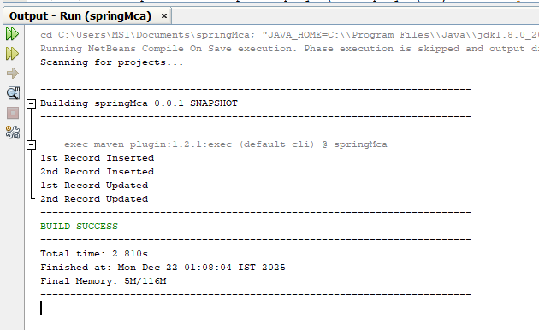

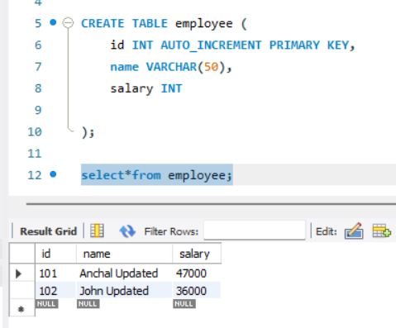

PRACTICAL 10

Write a program to create a simpleSpring Boot application that prints a message.

Step1:
Go to Spring Initializr. Select the type of project (Maven). Choose the language(Java).Select the Spring Boot version.
Fill in the project metadata. Add necessary dependencies (atleast spring- boot- starter-web). Click on “Generate” to download the project.

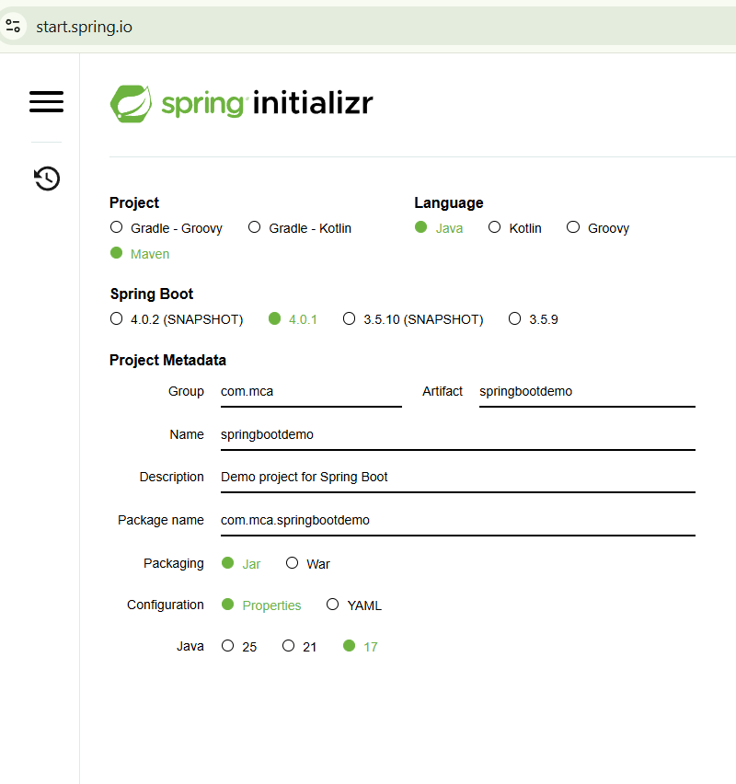
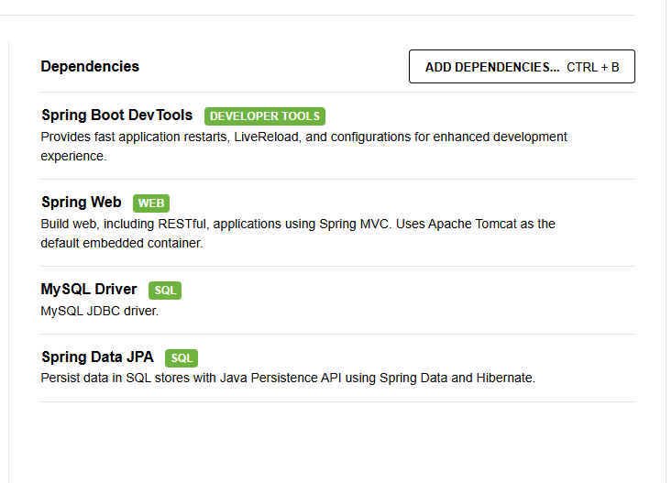

Step2:
Open Eclipse IDE. NavigatetoFile>Import. Select“Existing Maven Projects”. Click on “Next”. Click on “Browse” and navigate to the location where you downloaded the project. Make sure the pom.xml file is checked. Click on “Finish”.

SpringbootdemoApplication .java

package com.springmca.springbootdemo;
import org.springframework.boot.SpringApplication;
import org.springframework.boot.autoconfigure.SpringBootApplication;
import org.springframework.web.bind.annotation.GetMapping;
import org.springframework.web.bind.annotation.RestController;

@SpringBootApplication
public class SpringbootdemoApplication {

public static void main(String[] args) {
SpringApplication.run(SpringbootdemoApplication.class, args);
}
}

@RestController
class MyController {

@GetMapping("/")
public String quote() {
return "Hello Anchal !! Hero? No! We’re pirates! I love heroes, but I don’t wanna be one!";
}
}

pom.xml
<?xml version="1.0" encoding="UTF-8"?>
<project xmlns="http://maven.apache.org/POM/4.0.0"
xmlns:xsi="http://www.w3.org/2001/XMLSchema-instance"
xsi:schemaLocation="http://maven.apache.org/POM/4.0.0
https://maven.apache.org/xsd/maven-4.0.0.xsd">

<modelVersion>4.0.0</modelVersion>

<parent>
<groupId>org.springframework.boot</groupId>
<artifactId>spring-boot-starter-parent</artifactId>
<version>3.2.0</version>
<relativePath/>
</parent>

<groupId>com.springmca</groupId>
<artifactId>springbootdemo</artifactId>
<version>0.0.1-SNAPSHOT</version>
<name>springbootdemo</name>
<description>Spring Boot demo for Java 8</description>
<properties>
<java.version>17</java.version>
</properties>

<dependencies>
<!-- Spring Boot REST / Web -->
<dependency>
<groupId>org.springframework.boot</groupId>
<artifactId>spring-boot-starter-web</artifactId>
</dependency>
</dependencies>

<build>
<plugins>
<plugin>
<groupId>org.springframework.boot</groupId>
<artifactId>spring-boot-maven-plugin</artifactId>
</plugin>
</plugins>
</build>

</project>

Output:

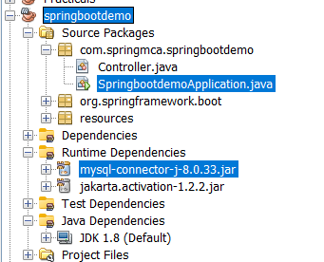

http://localhost:8080/

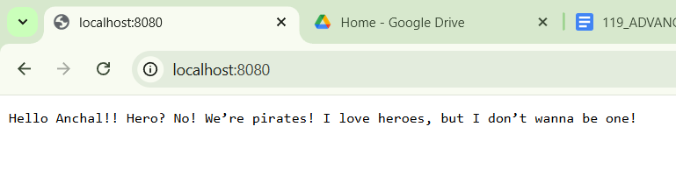

Write a program to demonstrate RESTful Web Services with spring boot.

Main Application Class - DemoApplicationTests.java

package com.springmca.springbootdemo;
import org.springframework.boot.SpringApplication;
import org.springframework.boot.autoconfigure.SpringBootApplication;
@SpringBootApplication
public class DemoApplicationTests {

public static void main(String[] args) {
SpringApplication.run(DemoApplicationTests.class, args);
}
}

Model Class - Student.java

package com.springmca.springbootdemo.model;
public class Student {

private int id;
private String name;
private String course;

public Student() {
}

public Student(int id, String name, String course) {
this.id = id;
this.name = name;
this.course = course;
}

public int getId() {
return id;
}

public void setId(int id) {
this.id = id;
}

public String getName() {
return name;
}

public void setName(String name) {
this.name = name;
}

public String getCourse() {
return course;
}

public void setCourse(String course) {
this.course = course;
}
}

REST Controller - StudentController.java

package com.springmca.springbootdemo.controller;
import com.springmca.springbootdemo.model.Student;
import org.springframework.web.bind.annotation.*;
import java.util.ArrayList;
import java.util.List;

@RestController
@RequestMapping("/students")
public class StudentController {

private List<Student> students = new ArrayList<>();

// GET all students
@GetMapping
public List<Student> getAllStudents() {
return students;
}

// GET student by ID
@GetMapping("/{id}")
public Student getStudentById(@PathVariable int id) {
return students.stream()
.filter(student -> student.getId() == id)
.findFirst()
.orElse(null);
}
// POST - add student
@PostMapping
public String addStudent(@RequestBody Student student) {
students.add(student);
return "Student added successfully";
}
// PUT - update student
@PutMapping("/{id}")
public String updateStudent(@PathVariable int id, @RequestBody Student student) {
for (Student s : students) {
if (s.getId() == id) {
s.setName(student.getName());
s.setCourse(student.getCourse());
return "Student updated successfully";
}
}
return "Student not found";
}

// DELETE - remove student
@DeleteMapping("/{id}")
public String deleteStudent(@PathVariable int id) {
students.removeIf(student -> student.getId() == id);
return "Student deleted successfully";
}
}

Output:
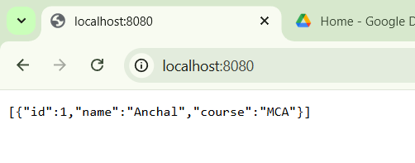

Write a program to demonstrate Database Connection with spring
CREATE DATABASE testdb;
USE testdb;
CREATE TABLE user (
id INT PRIMARY KEY,
name VARCHAR(255),
email VARCHAR(255)
);
pom.xml
<?xml version="1.0" encoding="UTF-8"?>
<project xmlns="http://maven.apache.org/POM/4.0.0" xmlns:xsi="http://www.w3.org/2001/XMLSchema-instance"
xsi:schemaLocation="http://maven.apache.org/POM/4.0.0 https://maven.apache.org/xsd/maven-4.0.0.xsd">
<modelVersion>4.0.0</modelVersion>
<parent>
<groupId>org.springframework.boot</groupId>
<artifactId>spring-boot-starter-parent</artifactId>
<version>4.0.1</version>
<relativePath/> <!-- lookup parent from repository -->
</parent>
<groupId>com.example</groupId>
<artifactId>springbootdemo</artifactId>
<version>0.0.1-SNAPSHOT</version>
<name>springbootdemo</name>
<description>Demo project for Spring Boot</description>
<url/>
<licenses>
<license/>
</licenses>
<developers>
<developer/>
</developers>
<scm>
<connection/>
<developerConnection/>
<tag/>
<url/>
</scm>
<properties>
<java.version>17</java.version>
</properties>
<dependencies>
<dependency>
<groupId>org.springframework.boot</groupId>
<artifactId>spring-boot-starter-data-jpa</artifactId>
</dependency>
<dependency>
<groupId>org.springframework.boot</groupId>
<artifactId>spring-boot-starter-webmvc</artifactId>
</dependency>
<dependency>
<groupId>com.mysql</groupId>
<artifactId>mysql-connector-j</artifactId>
<scope>runtime</scope>
</dependency>
<dependency>
<groupId>org.springframework.boot</groupId>
<artifactId>spring-boot-starter-data-jpa-test</artifactId>
<scope>test</scope>
</dependency>
<dependency>
<groupId>org.springframework.boot</groupId>
<artifactId>spring-boot-starter-webmvc-test</artifactId>
<scope>test</scope>
</dependency>
</dependencies>
<build>
<plugins>
<plugin>
<groupId>org.springframework.boot</groupId>
<artifactId>spring-boot-maven-plugin</artifactId>
</plugin></plugins>
</build></project>

src/main/resources - > application.properties
spring.application.name=springbootdemo
server.port=8083
spring.datasource.url=jdbc:mysql://localhost:3306/testdb
spring.datasource.username=root
spring.datasource.password=
spring.jpa.hibernate.ddl-auto=update
spring.jpa.show-sql=true

Main Class – DemoApplication1.java
package com.example.rest.db;
import org.springframework.boot.SpringApplication;
import org.springframework.boot.autoconfigure.SpringBootApplication;
@SpringBootApplication
public class DemoApplication1 {
public static void main(String[] args) {
SpringApplication.run(DemoApplication1.class, args);
System.out.println("Database Connected Successfully!");
}
}

Entity Class – User.java
package com.example.rest.db;
import jakarta.persistence.Entity;
import jakarta.persistence.Id;
@Entity
public class User {
@Id
private int id;
private String name;
private String email;
public int getId() {
return id;
}
public void setId(int id) {
this.id = id;
}

public String getName() {
return name;
}
public void setName(String name) {
this.name = name;
}

public String getEmail() {
return email;
}
public void setEmail(String email) {
this.email = email;
}
}

UserController.java
package com.example.rest.db;
import org.springframework.data.jpa.repository.JpaRepository;
public interface UserRepository extends JpaRepository<User, Integer> {
}

Repository Interface – UserRepository.java
package com.example.rest.db;
import org.springframework.web.bind.annotation.*;
@RestController
@RequestMapping("/user")
public class UserController {

private final UserRepository repo;

public UserController(UserRepository repo) {
this.repo = repo;
}

@PostMapping("/save")
public String saveUser(@RequestBody User user) {
repo.save(user);
return "User saved in database";
}
}

Output:

